**Crockery products**

1. Potato cutter
2. Stainless steel pressure cooker
3. Mandoline slicer
4. Ice crusher machine
5. Frozen food deforesting tray
6. Iron frying pan
7. Nonstick BBQ grill
8. Stainless steel food steamer
9. Microwave

**SANI1TERY PRODUCTS:**

1. Sinks
2. Bathtub
3. Taps
4. Hand shower
5. Soap dispenser
6. Toilet seat
7. Toilet roll holders
8. Towel rack

# **Electronics:**

1. Flat Screen TV
2. Digital Camera
3. Printer
4. Headphones
5. Mac Laptop
6. Wireless internet router
7. Stationary Game Console
8. Tablet

## **Home Appliances:**

1. Refrigerators
2. Sofas
3. Toaster
4. Cooker
5. Blender
6. Dishwasher
7. Coffee Machine
8. Freezer
9. Heaters

**Car Care:**

1. Car Polish
2. Car wax
3. Glass cleaners
4. Grit Guard
5. Car wash liquid
6. Wheel cleaner and wheel brush
7. Chamois and microfiber towels
8. Detail spray
9. Tyre shine
10. Shining sprays
11. Mats
12. Ceramic coatings

**SKIN PRODUCTS:**

1-Facial creams

2- Facial Toners

3 - Liquid Exfoliants

4 - Eye Creams

5- Facial Cleanser

6 - Facial Wax

7 - Face Oil

8 - Moisturizer

9 – Sunscreens

10 – Derma Rollers

11- Eye Vitamin serums

**GROCERY PRODUCTS:**

1 – Soft Drinks

2 - Avocado

3 - Berries

4 - Breakfast Cereals and instant oatmeal

5 – Block Cheese

6 – Dairy Products (Milk, yogurt etc)

7 – Fresh Fruits

8 - Cookies

9 – Fruit Juices

10 – Fresh and Frozen Beef

**GARMENTS:**

**Men’s:**

1. Shorts
2. T-shirts
3. Suit coat
4. Waistcoat

**Women’s:**

1. Tops
2. Skirts
3. Coast Dress
4. Maxi

**Fitness Items:**

1. Hammer strength
2. Inspire Treadmill
3. Inspire Elliptical

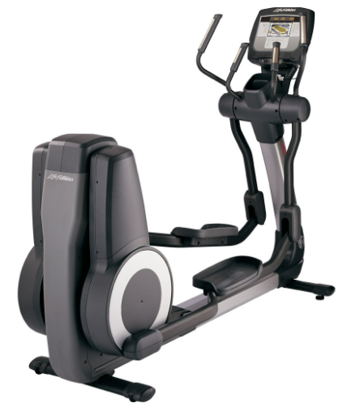

1. Recumbent Bike
2. Elliptical Cross trainer
3. Adjustable dumbles
4. Adductor machine
5. Standing calf
6. Abdominal crunch
7. Machine leg curl

**Shoes Items:**

**Women’s:**

1. Heels
2. Flats
3. Wedges
4. Thigh high boots
5. Pumps

**Men’s:**

1. Hiking shoes
2. Loafers
3. Sneakers
4. Boat shoes
5. Sandals